- The UK Monetary Policy Committee voted to keep Bank Rate at 5% at its September meeting. We expect the next cut will be 25bps in November, in line with the committee's message that policy will be loosened gradually.
- The possibility of more aggressive tightening of fiscal policy and a recent change in tone by central banks globally mean the risks are skewed towards a steeper fall in Bank Rate around the turn of the year – either via a 50bps cut or the MPC opting for back-to-back 25bps cuts.
- The MPC also voted to reduce the stock of gilts held in the Asset Purchase Facility by £100bn over the next year. Given the high level of redemptions due this year, this implies a sharp reduction in the level of gilt sales. But we don't think this move signals that the pace of quantitative tightening will slow from 2025, as markets seem to expect.
The Bank of England's Monetary Policy Committee voted 8-1 to leave Bank Rate at 5% at today's meeting, as we expected. Committee member Swati Dhingra was the sole dissenter, voting for another 25bps cut.
The minutes suggested the MPC had concluded that little had changed since the August meeting, when the MPC had indicated its intention to loosen policy gradually. In a nod to the Bernanke review, the minutes set out three scenarios for inflation, ranging from underlying pressures dissipating rapidly, to one where global shocks have caused structural changes in price- and wage-setting. But there was no indication of the balance of views about which scenario was the more likely. Similarly, the BoE made little effort to indicate the differences in views among those voting to keep Bank Rate on hold.
We regard another rate cut in November as almost certain. It would be consistent with the message that the MPC reiterated in September's minutes, that "in the absence of material developments, a gradual approach to removing policy restraint would be warranted". And as in June, the MPC pointed to the importance of the upcoming forecast round as a potential trigger for changing policy. Other dovish signals came from slight concerns about the strength of global growth, and the latest survey of the BoE's regional agents providing reassuring news on the likely trajectory of pay growth.
We think the risks are skewed towards the MPC cutting more aggressively around the turn of the year, either by following the Federal Reserve's lead and cutting by 50bps, or by cutting at successive meetings. More aggressive tightening of fiscal policy in the Budget on October 30 would be an obvious trigger for faster monetary loosening. There's also been a clear change of tone by central banks globally in recent months, moving from a total focus on inflation towards giving greater consideration to growth concerns.
The BoE's move to a more forward-looking approach was part of this shift, but last night's move by the Fed has upped the ante. That the BoE has moved away from focusing on specific indicators of inflation persistence to making broader judgements means it has more flexibility to react if growth worries deepen.
The MPC also voted to reduce the stock of gilts held in the Asset Purchase Facility (APF) by £100bn over the next year. This represents the same pace of quantitative tightening as over the past year. But with £87bn of redemptions due over the next year, this means that the level of gilt sales will fall to just £13bn from £50bn last year (Chart 1).
The minutes and accompanying market notice offered no indication of where the MPC expects to go from here. Last month's BoE Market Participants Survey (MaPS) suggests that market participants expect the pace of QT will fall from 2025-2026, although considering that the value of redemptions will drop sharply, this implies the level of gilt sales will increase again.

Chart 1: Maintaining the pace of QT implies a sharp fall in the level of gilt sales
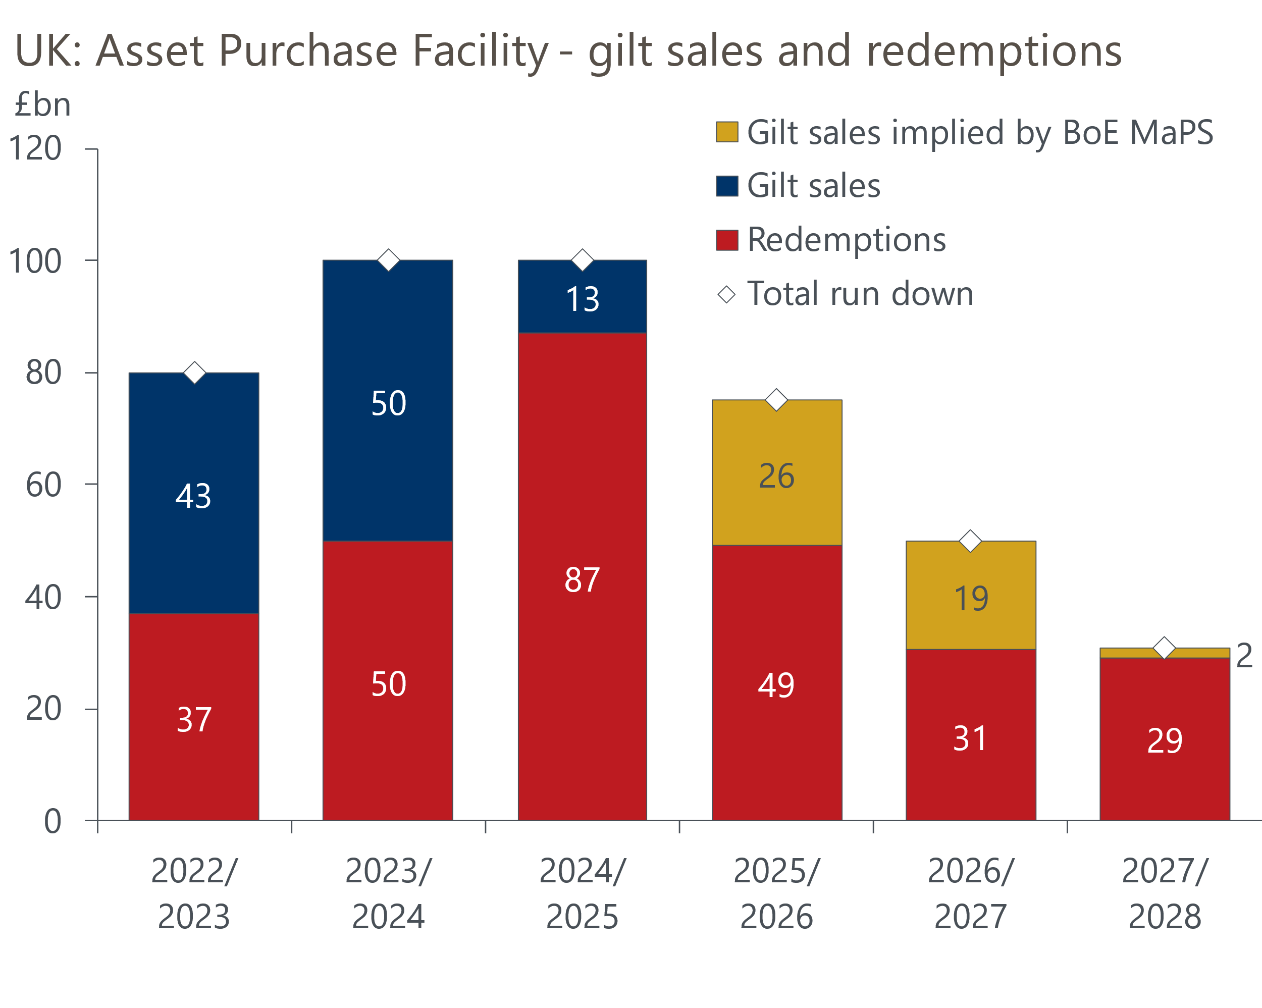
Sources: Oxford Economics calculations using data from Haver Analytics & Bank of England
The expectation that the pace of QT will slow appears to partly reflect concerns that, unless offset by other BoE facilities, the current pace of APF rundown may soon leave banks with inadequate reserves at the BoE. This could add upward pressure and volatility to short-term interest rates.
We think this concern is misplaced because the BoE can use a major expansion of short-term repos as the counterpart to a persistently high level of bank reserves. With the box in August's Monetary Policy Report making clear that the BoE think that QT is progressing well and having a negligible impact on gilt yields and the real economy, we think the BoE will continue to run down the APF at the current pace in subsequent years until all the gilts have been sold.

Key passages from the MPC minutes
“Eight members preferred to maintain Bank Rate at 5% at this meeting. Wage and price-setting had continued to normalise and UK activity growth had been broadly in line with expectations, although there was some greater uncertainty around the near-term global outlook. There was a range of views among these members on the degree to which the unwinding of past global shocks, the normalisation in inflation expectations and the current restrictive policy stance would lead underlying domestic inflationary pressures to continue to unwind, or whether these pressures could prove more entrenched, possibly as a result of more structural factors or greater momentum in demand. Despite these differences of view, the current policy stance was judged to be appropriate. For most members, in the absence of material developments, a gradual approach to removing policy restraint would be warranted."
Our interpretation: This paragraph alludes to there still being two distinct groups, but offers far less colour on the divisions than there was in the August minutes. The key point is that if the outlook evolves in line with expectations, then the majority expect to gradually cut Bank Rate.
"One member preferred a 0.25 percentage point reduction in Bank Rate at this meeting. Bank Rate needed to become less restrictive now to enable a smooth and gradual transition in the policy stance, and to account for lags in transmission. CPI inflation had been on a firm downward trajectory for some time. Data developments remained consistent with CPI inflation staying sustainably at target, given the further easing in the labour market, continued falls in inflation expectations and forward-looking indicators of pass-through, and the subdued outlook for demand."
Our interpretation: Dhingra has long advocated the type of forward-looking approach that her colleagues have recently adopted, so it was no surprise to see her vote for a second successive rate cut. We expect her to continue to vote for rate cuts at every meeting for the foreseeable future. Having switched to voting for cuts before his fellow internal members, there was some uncertainty about whether Dave Ramsden would join Dhingra in voting for another cut. That he voted with the majority suggests Ramsden is fully signed up to the gradual approach advocated by the other internal members.
"Monetary policy would need to continue to remain restrictive for sufficiently long until the risks to inflation returning sustainably to the 2% target in the medium term had dissipated further. The Committee continued to monitor closely the risks of inflation persistence and would decide the appropriate degree of monetary policy restrictiveness at each meeting."
"The MPC would make a full assessment of recent and prospective developments as part of its forthcoming November forecast round."
Our interpretation: The first paragraph matches the wording used in August. The second paragraph is similar to June, when the MPC had flagged that the forecast round would be a potential trigger for policy change. As the November meeting comes a week after the Budget, which is likely to announce further tightening of fiscal policy, this increases the probability of another cut at the next meeting.

